SMART 3D: The Interactive Classroom
Stephen Bingham: stephen.d.bingham@hotmail.com
Sylvia Dabrowski: srdabrowski@gmail.com

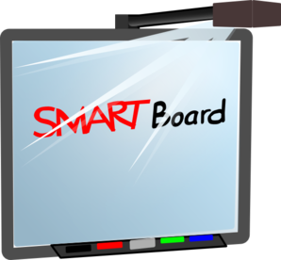Overview
Introduction
http://3dsmart.wikispaces.com/

SMART + Notebook
Places to Look
Interactive Centers & Group Work
Group Discussion

SMART + iPad & Apple TV
Books on Tape | Math | Whiteboard | Science & Social Studies | Chapter & DIY Books | Common Core | Genius | Science & Social Studies | Splashtop | Project Share

SMART + iPevo
Student Work
Essays/Extended Response
Science Experiments

Computer Station
Differentiated Work
Centers
Group Discussion

Closing
Check Out These Apps!
Literature | K-2 Grammar/Phonics | 2-3 Grammar | Math | Miscellaneous
Story Kit  Wild Fables  Story Chimes  Peter Light  Mee Genius  Read Me Stories  Toy Story  Four Seasons  Shoemaker  Watson  iStoryBooks | Alphabet Match  ABC’s and Me  Match the Letter  My First Words  Come Learn Spelling  K-3 Sight Words  Spell Animals  ABC Lite  BB Magic Lite  Magnetic ABC  Z is for Zebra  Sight Words Touch  Sight Speller  Word Bingo  Starfall ABCs  Sound Sorting  Tic Tac Toe | Textropolis  UWord Search  Chicktionary  Bluster | Multiply Free  Brain Tuner  Math Bingo  Math Drills Lite  Math Ninja  Motion Math  Motion Math HD  Multiples  That Quiz Math  Pizza 1  Pearl Diver  Coin Math  McGraw Hill (x, +, fractions, squeeze, divisibility)  Mad Math  Hungry Fish  MathBoard  Math Bingo | Educreations  Stack the States  Dictionary.com  National Geographic Kids  PBS Kids  Safari Montage  BrainPop  String AR Showcase

